**The Money Maze**

Go through the maze, collecting and losing your money as you go. You may not go through any cell more than once, and can only go into a cell through a gap, for example, you may not go from 5 to 6, or from 7 to 3.

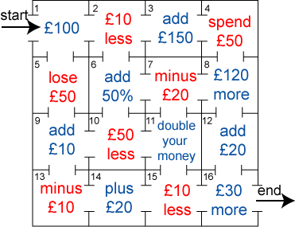

Which route gives you the highest return? How much is it?   
Which route gives you the lowest return? How much is it?